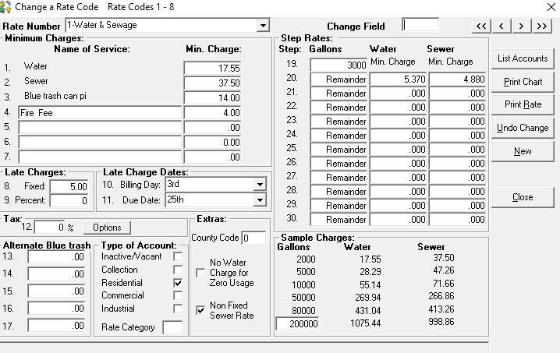

Started 04/01/24 … Previously $11.70 (water) and $25.00 (sewer)
Started 01/29/25 … Previously $17.55 (water) and $37.50 (sewer) … Min water $5.37 and Min sewer $4.88
Changed to Water (Base) $30.00 … 71% increase Min water $9.18
Sewer (Base) $95.00 … 154% increase Min sewer $12.40
Correction 02/18/25 (erroneously increased to $95 should have been $65.
Changed to Water (Base) $30.00 … 71% increase Min water $9.18 … This was correct $5.37 (previous) + $3.81 (previous X % increase) = $9.18
Sewer (Base) $65.00 … 42.30% increase $4.88 (previous) + $3.58 (previous / % increase) = Min sewer $8.46

