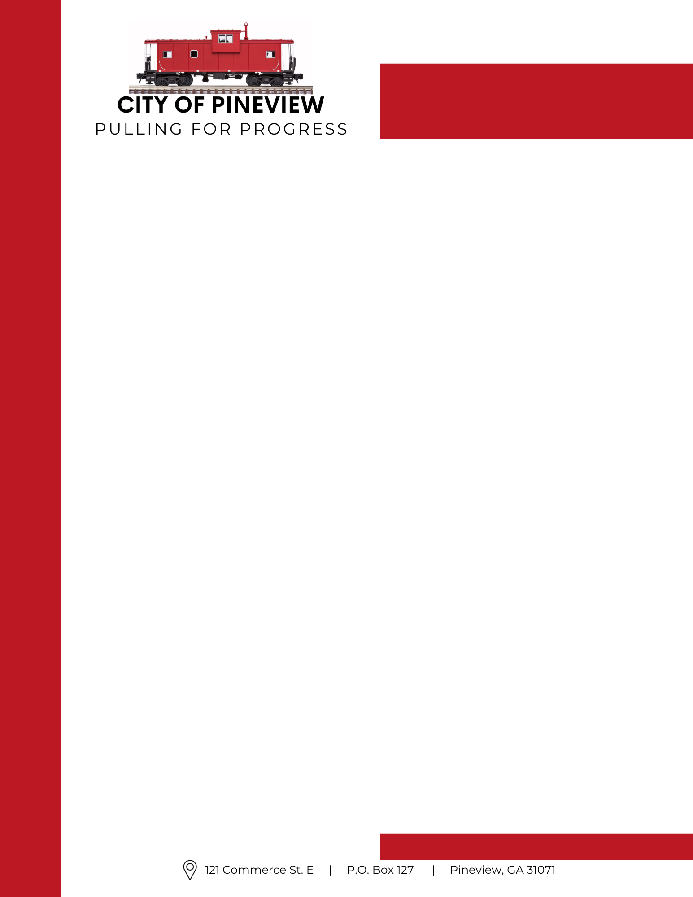
Ph: (229) 624-2422
Fax:(229) 624-2439
Email: pineviewcity@windstream.net

City of Pineview
Notice of Water Rate Change
Effective June 2024, the City of Pineview implemented a change to the base water rate. The previous base rate of $13.00 was increased to $23.00.
This adjustment was approved by City Council to help cover the rising costs of water system operations, maintenance, and improvements to ensure continued reliable service to residents and businesses within the City of Pineview.
For questions regarding this change, please contact Pineview City Hall at 229-624-2422 and/or via email: pineviewcity@windstream.net

