2025 Stormwater Rates:
Cobb County
City/County/Authority Name: | Cobb County
Contact Name: | N/A
Contact Phone Number: | 770-419-6435
Contact Email: | stormwater@cobbCounty.org
Webpage Link: | https://www.cobbcounty.gov/water/stormwater-management

Rates:
Base Rate: | $4.75
How many square feet is an ERU? | 3,700
How much is charged per ERU? | N/A
Formula for Calculation: | Flat fee
Offer Credits? Yes or No | Yes  https://assets.cobbcounty.gov/files/2025-12/Stormwater-Credit-Manual-11-12-2025.pdf
How is it billed? (Utility bills, separate bills, property taxes, etc.) | Utility bill
Are there other rates offered: commercial, industrial, government, discounted rates, etc.? | Yes, commercial
Nonresidential Fee: | $4.75 per 3,700
Multi-Family Fee: | $4.75 flat fee
Additional Information:  (Include screenshots if easier) | 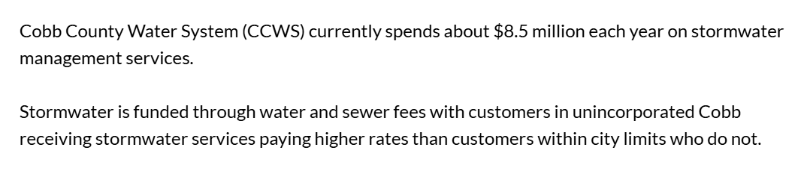

Online Rate Sheet: (include screenshot)

